EYFS Progression of skills and assessment checkpoints - Writing
Birth-Three  -Enjoy drawing freely.  -Add some marks to their drawings, which they give meaning to. For example: “That says mummy.”  -Make marks on their picture to stand for their name.  Handwriting  . Develop manipulation and control.  . Explore different materials and tools. |  | Three- Four Years  . Use some of their print and letter knowledge in their early writing. For example: writing a pretend shopping list that starts at the top of the page; write ‘m’ for mummy.  • Write some or all of their name.  . Write some letters accurately.  Handwriting  .Use a comfortable grip with good control when holding pens and pencils.  .Show a preference for a dominant hand. |  |  | Reception  . Form lower-case and capital letters correctly.  . Spell words by identifying the sounds and then writing the sound with letter/s.  . Re-read what they have written to check that it makes sense.  . Write short sentences with words with known letter-sound correspondences using a capital letter and full stop.  Handwriting  Develop their small motor skills so that they can use a range of tools competently, safely and confidently. Suggested tools: pencils for drawing and writing.  Develop the foundations of a handwriting style which is fast, accurate and efficient. |  |  |  | Writing- ELG .  . Write recognisable letters, most of which are correctly formed. Writing-ELG  • Spell words by identifying sounds in them and representing the sounds with a letter or letters. Writing-ELG  • Write simple phrases and sentences that can be read by others. Writing-ELG  Handwriting  . Hold a pencil effectively in preparation for fluent writing- using the tripod grip in almost all cases. FMS-ELG
Early Steps  Making Marks | I explore making marks, but I do not communicate meaning.  Random scribbling.  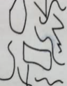 |  | I draw basic pictures.  I use lines to look like writing. Scribble writing  Left to right direction  I begin to assign meaning.  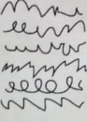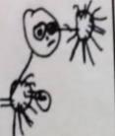 | I write symbols and shapes that look like writing.  I assign meaning to the marks  Attempts to write name  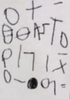 |  | I write random letters but there is no connection between letters and sounds. I talk about my writing and give meaning.  Writes name from memory  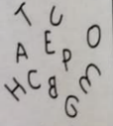 | I use letter strings which travel from left to right and top to bottom.  I attempt to ‘read’ my writing.  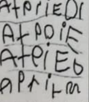 | I write letters with spaces between them to resemble the idea of words. |  | I copy words that I see in the environment around me.  I often do not know what the words say.  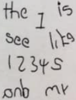
Developing Writing  Words | I am beginning to hear initial sounds and attempt to write these down.  m - mum  letter for name |  | I can hear initial sounds in words and write the letters down to match.  c - cat  d- dog  p - pig | I can write short strings of letters to represent words. Two or three letters in sequence. Hearing /writing final sounds first and then medial. Left to right.  muy - mummy  pto - potato  sbr - strawberry |  | I can spell out and write down vc cvc words by matching letters and sounds.  at in up  cat  dog  pig | I can write High Frequency decodable and tricky words from memory.  mum dad. and can  I go to the no into | I can spell out words with consonant clusters, vowel digraphs and trigraphs.  buzz fill. mess  ship. chip thing rush  boat sheep now soil  chair night. Pure. |  | I write more challenging words with a sound knowledge of Phase 2, 3 and 4 phonics. Phase 5-I use different spelling choices and more syllables. Plausible attempts  Phase 2, 3 and 4 HF words  Adjacent consonants  Alternative graphemes  Split digraphs- home make
Developing Writing  Sentences | I can formulate and say a simple sentence for writing. |  | I can orally compose a sentence and hold it in my memory before I start to write it.  Repeats & recalls | I can write a series of beginning letters and sounds for my phrase. There may be no spaces between words.  Begins to be readable to others.  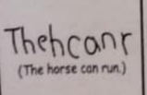 |  | I can recall the order of words in my sentence. I start to put finger spaces between my words and to use known words. Writing is readable. I start to read my sentence. | I can write a sentence with a full stop and capital letter. I can re-read it and check that it makes sense. Others can read my sentence.  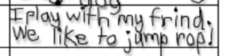 | I can write spaces between all the words in my sentences. Some punctuation may be used. Medial and end sounds evident including vowels in my spellings. |  | I can write two or more sentences using real spellings and silent letters. Most sentences have the correct beginning and end punctuation.
Text forms and purposes | I attempt to write simple labels. |  | I can write simple labels | I can write simple lists. |  | I can write short captions and messages.  I can write lists, greeting cards and menus. | I can write captions  I can write instructions.  I can write postcards. | I can write simple stories with a beginning, middle and end.  I can write a letter. |  | I can write stories with narratives and storytelling language.  I can write at length.

