
Four Oaks Primary School
Core Text Overview

Reception ‘Anchor texts’ are planned as part of the Narrative Immersion approach used to develop children’s creative talk and vocabulary (both of which are component skills required if children are to become fluent readers who can comprehend accurately). These texts are studied in depth and are used to generate themes for purposeful play and learning opportunities in all areas of the EYFS curriculum. ‘Satellite texts’ which link to the theme of the ‘Core text’ are read daily to the children so they encounter a wide range of text types over the course of a unit. Please see the EYFS page for more information on the use of the Narrative Immersion Approach in our Nursery and Reception classes.

Year Group | Autumn 1 | Autumn 2 | Spring 1 | Spring 2 | Summer 1 | Summer 2
EYFS Narrative Immersion Theme Anchor Book  A | Star in a Jar  By Sam Hay  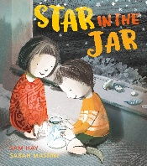 | The Magic Paintbrush  By Julia Donaldson  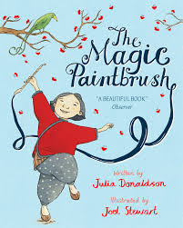  One Plastic Bag  By Miranda Pail  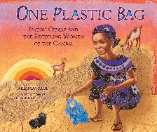 | The Tiger Who Came to Tea  By Judith Kerr    Figurative/symbolic text (5 Plagues) | Jack and the Flumflum Tree  By Julia Donaldson  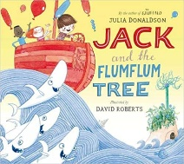 | Dear Mother Goose  By Michael Rosen  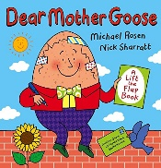 | The Snail and the Whale  By Julia Donaldson  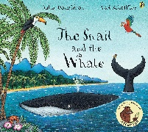
Linked Non-Fiction Satellite Text  A | Look Inside: Space by Rob Lloyd Jones and Benedetta Giaurfe  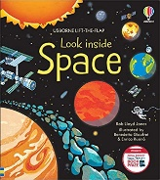 | Rubbish and Recycling  by Stephanie Turnbull  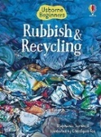 | Let’s Celebrate  by Kate Depalma  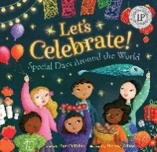 | My First Book of Transport  by Collins  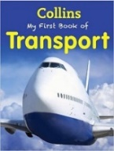 | People Who Help Us: Doctor  by Amanda Askew   | Let’s Look at Snails  by L. Hamilton Waxman  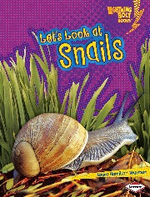
EYFS Narrative Immersion Theme Anchor Book  B | Supertato  By Sue Hendra  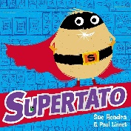 | Stick Man  By Julia Donaldson  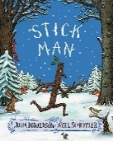 | Dear Fairy Godmother…  By Michael Rosen  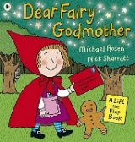 | Little Red and the Very Hungry Lion  By Alex T Smith  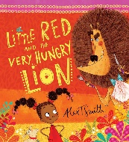 | The Paper Dolls  By Julia Donaldson  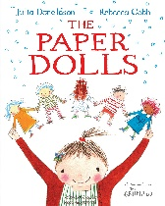 | The Night Pirates  By Peter Harris  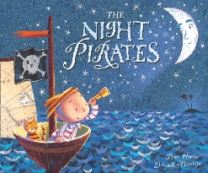
Linked Non-Fiction Satellite Text | Good For Me: Healthy Food  By Sharon Coan   | Changing Seasons  By Sian Smith  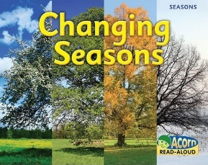 | Life Cycle of a Duck  By Kirsty Holmes  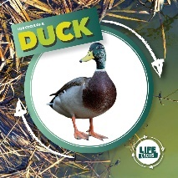 | First Atlas  by Miles Kelly  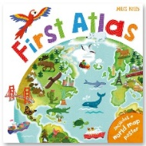 | First Facts: Bugs  By DK  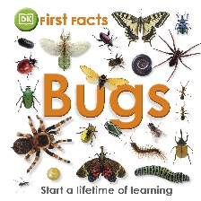 | My First Book of Transport  by Collins

