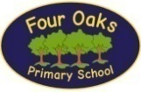
Four Oaks Primary School
Core Text Overview
The texts listed below are ‘Core texts’ for KS1 and KS2. These books are used to support the development of reading and writing (please see KS1 and KS2 Writing Overviews for more information on planned writing outcomes). Children will also study other fiction texts, non-fiction texts and poetry texts in their reading lessons each term. Please see the supporting ‘Poetry Overview’ for details on the poems taught in each year group. Additionally, KS1 and KS2 will use supplementary extracts from texts which pose five common challenges for children as readers. Doug Lemov describes these barriers as the ‘5 Plagues of the Developing Reader’ (Reading Rediscovered, 2016) and outlines them as this: Archaic text, Non-linear time sequence, Complexity of narrator, Complexity of plot and Resistant text. Children will be exposed to a range of each plague across each Years 1-6.

Reception ‘Anchor texts’ are planned as part of the Narrative Immersion approach used to develop children’s creative talk and vocabulary (both of which are component skills required if children are to become fluent readers who can comprehend accurately). These texts are studied in depth and are used to generate themes for purposeful play and learning opportunities in all areas of the EYFS curriculum. ‘Satellite texts’ which link to the theme of the ‘Core text’ are read daily to the children so they encounter a wide range of text types over the course of a unit. Please see the EYFS page for more information on the use of the Narrative Immersion Approach in our Nursery and Reception classes.

Year Group | Autumn 1 | Autumn 2 | Spring 1 | Spring 2 | Summer 1 | Summer 2
EYFS Narrative Immersion Theme Anchor Book  A | Star in a Jar  By Sam Hay  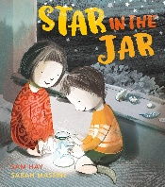 | The Magic Paintbrush  By Julia Donaldson  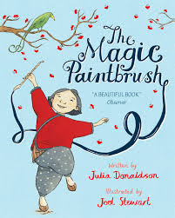  One Plastic Bag  By Miranda Pail  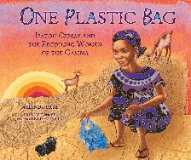 | The Tiger Who Came to Tea  By Judith Kerr  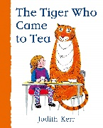  Figurative/symbolic text (5 Plagues) | Jack and the Flumflum Tree  By Julia Donaldson  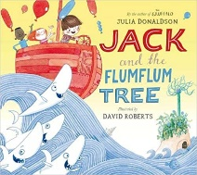 | Dear Mother Goose  By Michael Rosen  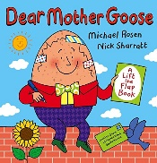 | The Snail and the Whale  By Julia Donaldson  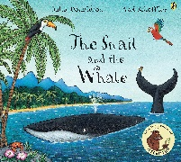
Linked Non-Fiction Satellite Text  A | Look Inside: Space by Rob Lloyd Jones and Benedetta Giaurfe  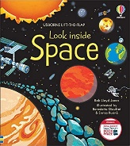 | Rubbish and Recycling  by Stephanie Turnbull  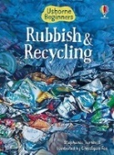 | Let’s Celebrate  by Kate Depalma  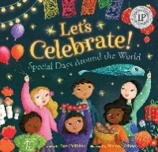 | My First Book of Transport  by Collins   | People Who Help Us: Doctor  by Amanda Askew  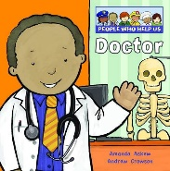 | Let’s Look at Snails  by L. Hamilton Waxman  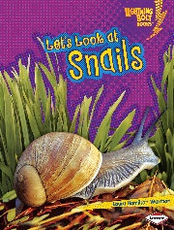
EYFS Narrative Immersion Theme Anchor Book  B | Supertato  By Sue Hendra  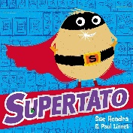 | Stick Man  By Julia Donaldson  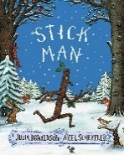 | Dear Fairy Godmother…  By Michael Rosen  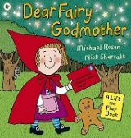 | Little Red and the Very Hungry Lion  By Alex T Smith  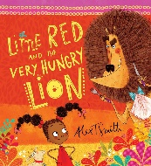 | The Paper Dolls  By Julia Donaldson  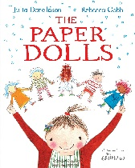 | The Night Pirates  By Peter Harris  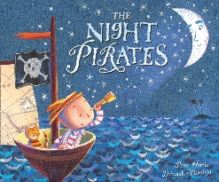
Linked Non-Fiction Satellite Text | Good For Me: Healthy Food  By Sharon Coan  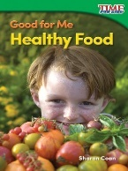 | Changing Seasons  By Sian Smith  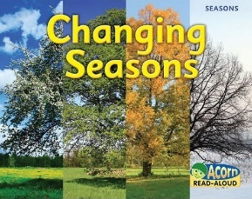 | Life Cycle of a Duck  By Kirsty Holmes  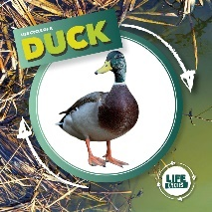 | First Atlas  by Miles Kelly  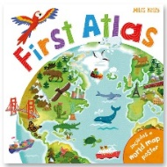 | First Facts: Bugs  By DK  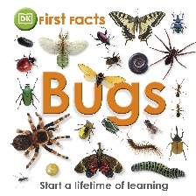 | My First Book of Transport  by Collins
Year 1 | Peace at Last  By Jill Murphy  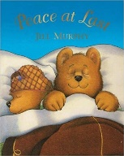  Beegu  By Alexia Deacon  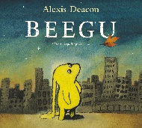  Inclusion; difference; acceptance; friendship; loneliness | The Queen’s Hat  By Steve Antony  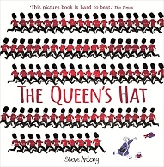  Helping other; friendship; loyalty; UK landmarks  How the Grinch Stole Christmas  By Dr Seuss  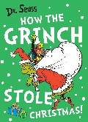  Transformation; community; love | Goldilocks and Just the One Bear  By Leigh Hodgkinson  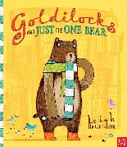  Empathy; kindness; family  Mr Wolf and the Three Bears  By Jan Fearnley  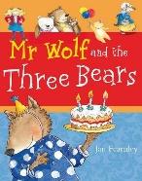  Revenge; behaviour; bullying | The Man on the Moon  By Simon Bartram  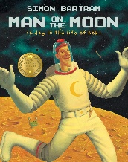  Space  By Sarah Powell  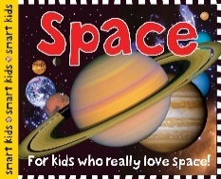 | Gigantysaurus  By Jonny Duddle  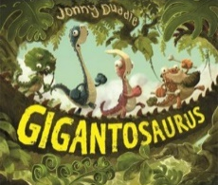  Being truthful; honesty  How to Look after your Dinosaur  By Jason Cockcroft  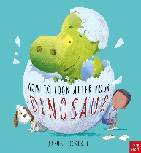 | Anna Hibiscus Double Trouble  By Atinuke  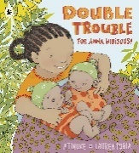  Handa’s Surprise  By Eileen Browne  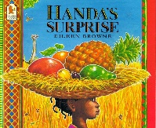  Meerkat Mail  By Emily Gravett  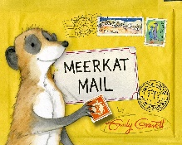
Non-Fiction | Mary Seacole  By John Malam  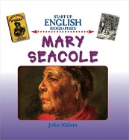  Strong, female protagonist | Weather  by Catrina Clarke  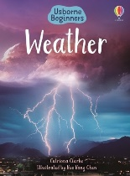 | Spring: Season of the Year  by Harriet Brundle  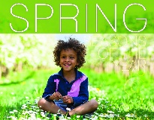 | A Journey Through Space  by Steve Parker and John Haslam  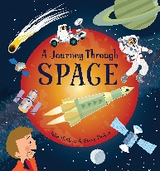 | Dinosaurs  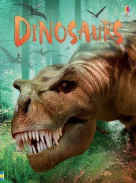  by Stephanie Turnbull | Seashore  by Lucy Bowman  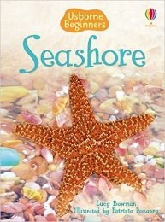
Year 2 | The Big Bad Owl  By Steve Smallman  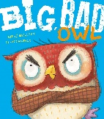  Dealing with emotions  Gorilla  By Anthony Brown  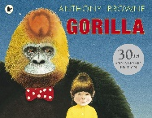  Strong, female protagonist  Loneliness; friendship  The Mystery of the Missing Cake  By Claudia Boldt  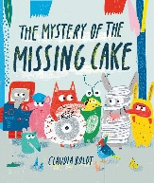 | Inside the Villains  by Clotilde Perrin  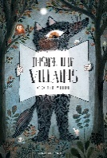  The Three Pigs  By David Wiesner  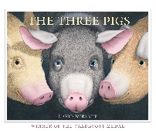  Challenges stereotypes  Moral reasoning  Mogs’ Christmas Calamity  (Film clip linked to text also used)  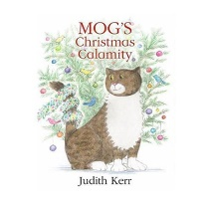 | That Moose Belongs to Me  By Oliver Jeffers  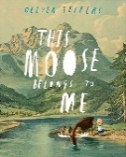  Friendship; ownership  The Way Back Home  By Oliver Jeffers  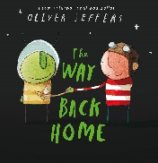  Race (protected characteristic)  Friendship  The Heart and the Bottle  By Oliver Jeffers  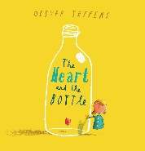  Figurative/symbolic text (5 Plagues)  Grief; loss; dealing with emotions  Strong, female protagonist | Tree: Seasons Come, Season Go  By Britta Teckentrup  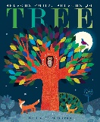  Changing seasons  Don’t Put Mustard in the Custard  By Michael Rosen  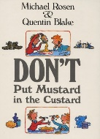  I Don’t like Poetry By Joshua Siegel  (You’re Never Too Big for A Hug)  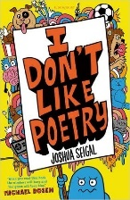 | Something Else  By Kathryn Cave  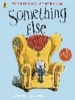  Disability (protected characteristic)  Friendship; being yourself  Elephant Me  By Giles Andreae  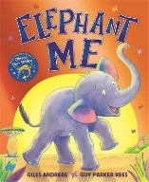  being yourself | George’s Marvellous Medicine  By Roald Dahl  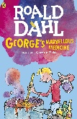  Internal journey; discovery  Poetry: Beatles Lyrics  
Non-Fiction | Collection of Instructions  (A range of instructional texts are explored) | Kings and Queens  By Tony Robinson  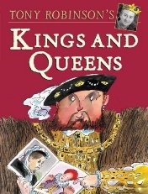 | A Stroll through the Seasons  by Kay Barnham  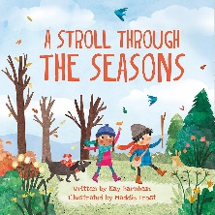 | The Great Fire of London  By Emma Adams  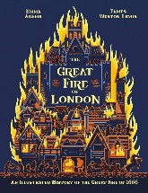 | Book of Planet Earth  by Megan Cullis and Matthew Oldham  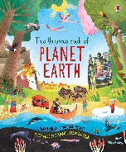 | Little People Big Dreams: Rosa Parks  By Lisbeth Kaiser  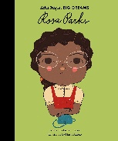  Little People Big Dreams: John Lennon  By Maria Isabel Sanchez Vegara  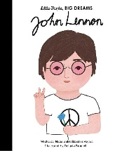
Year 3 | The Minpins  By Roald Dahl  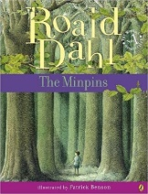  Child hero  Age (protected characteristic)  The Sheep-Pig  By Dick King Smith  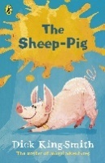  Race (protected characteristic)  Stereotypes; bullying | Bill’s New Frock  By Anne fine  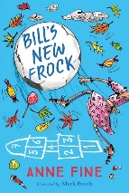  Gender reassignment (protected characteristic) | The Iron Man  By Ted Hughes  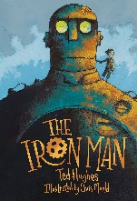  Figurative/symbolic text (5 Plagues) | Arthur and the Golden Rope  By Joe Todd Stanton  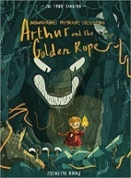  Age (protected characteristic)  Bravery; linked to Norse mythology | The Egyptian Cinderella  By Shirley Climo  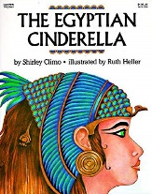  Strong, female protagonist | Escape from Pompeii  By Christina Balit  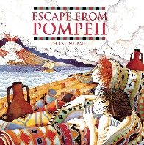  Links to Geography and Roman History
Non-Fiction | The Not Bad Animals  By Sophie Corrigan  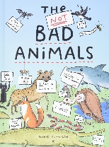 | Fantastically Great Women Who Changed the World by Kate Pankhurst  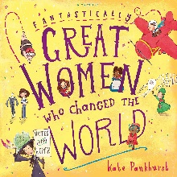  Strong, female protagonists | Magnificent Machines  by Pie Corbett  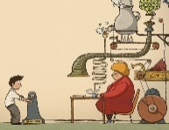 | The Orchard Book of Roman Myths  By Geraldine McCaughlean  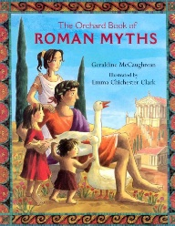  Roman myths linked to Roman History | So, You Think You've Got It Bad: A Kid's Life in Ancient Egypt  By Chae Strathie & Marisa Morea  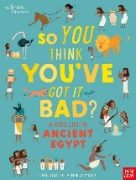 | Everything Volcanoes and Earthquakes  by National Geographic  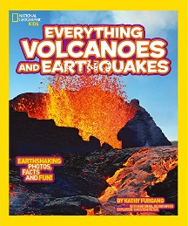
Year 4 | The Journey  By Aaron Becker  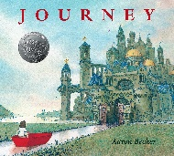  Strong, female protagonist  Determination | Harry Potter and the Philosopher’s Stone  By JK Rowling  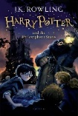  Race (protected characteristic)  Bullying | The Firework-Maker’s Daughter  By Philip Pullman  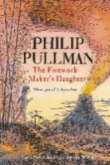  Non-linear time sequence text (5 Plagues)  Strong, female protagonist | Varjak Paw  By SF Said  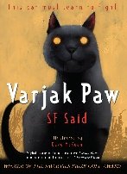  Perseverance, courage, family, bullying | The Miraculous Journey of Edward Tulane  By Kate DiCamillo  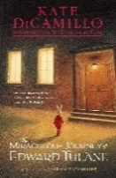  Loss, recovery, kindness, compassion, self-discovery | Cloud Busting  By Malorie Blackman  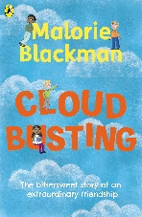  Resistant text (5 Plagues)
Non-Fiction | So, You Think You’ve Got It Bad by Chae Strathie  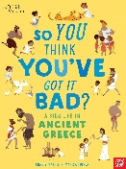 | Discovering Science  by Miles Kelly Publishing  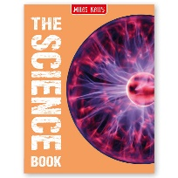 +Cracking Comprehension  Comprehension texts linked to science topic | Celebrations Around the World  By Katy Halford  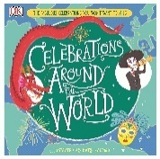 | Why Water’s Worth It  By Lori Harrison  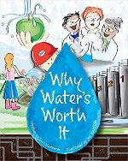 | Everything Anglo-Saxons  By National Geographic  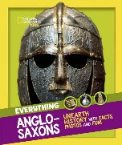 | Bully Busters Website  http://www.bullybusters.org.uk /why_do_people_bully/
Year 5 | Wonder  By RJ Palacio  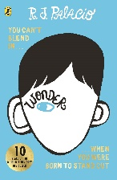  Disability (protected characteristic) | Cosmic  By Frank Cottrell – Boyce  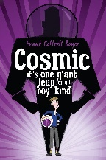  Disability (protected characteristic)  Age (protected characteristic) | Beowolf  By Michael Morpurgo  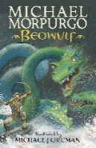  Anglo-Saxon legend (linked to Norse mythology) | Brightstorm  By Vashti Hardy  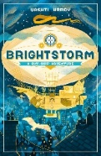  Disability (protected characteristic)  Strong, female protagonist  Gender (protected characteristic) | Explorer  By Katherine Rundell  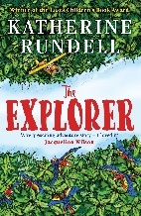  Age (protected characteristic) | The Nowhere Emporium  By Ross Mackenzie  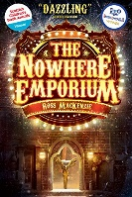  Orphaned child; bullying
Non-Fiction | You are Awesome  by Matthew Syed  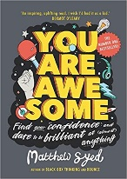  Resiliency | The Extraordinary Life of Katherine Johnson  by Devika Jina  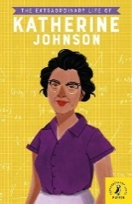  Strong, female protagonist  Race (protected characteristic)  Hidden Figures  By Margot Lee Shetterley  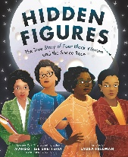  Strong, female protagonist  Race (protected characteristic) | Everything Vikings  by National Geographic  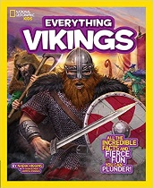 | Inspirational People:  Amelia Earhart  By National Geographic  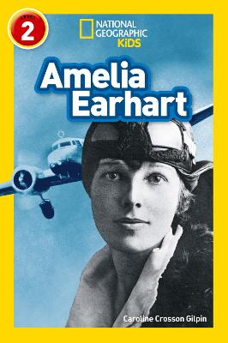  Strong, female protagonist | The Lost Book of Adventure  From the Notebooks of the Unknown Adventurer  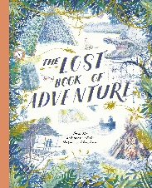 | Should Wild Animals Perform in Circus Acts?  (BBC Newsround)  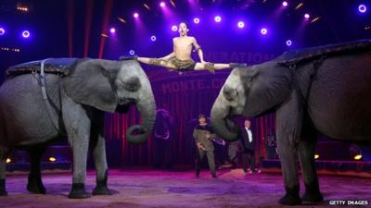
Year 6 | Holes  By Louis Sachar  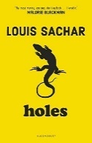  Non-linear time sequence (5 Plagues)  Race (protected characteristic) | Rose Blanche  By Ian McEwan and Roberto Innocenti  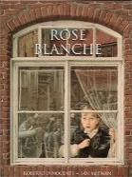  Strong, female protagonist | The House with Chicken Legs  By Sophie Anderson  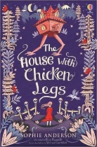  Strong, female protagonist | No Ballet Shoes in Syria  By Catherine Bruton  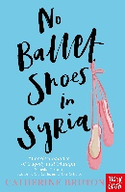  Strong, female protagonist  Refugee narrative  The Island  By Armin Greder  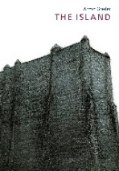  Refugee narrative  Race (protected characteristic) | The Goldfish Boy  By Lisa Thompson  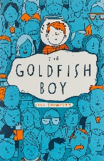  Disability (protected characteristic) | The London Eye Mystery  By Siobhan Dowd  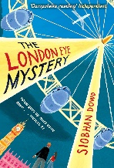  Disability (protected characteristic)  Race (protected characteristic)
Non-Fiction | History of Crime and Punishment  (Comprehension Ninja) | The Kindertransport Mission  BBC News Articles  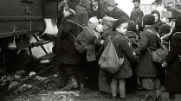  Race (protected characteristic) | Baba Yaga Factsheet and Russian Folklore  By Sophie Anderson  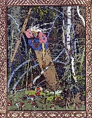 | Who are Refugees and Migrants? What Makes People Leave Their Homes?  By Michael Rosen and Annemarie Young  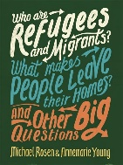  Race (protected characteristic)  Charles Darwin: On the Origin of the Species  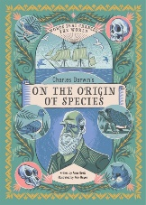  By Anna Brett | A range of articles on children’s mental health and well being  (To be decided based on the needs of the Cohort) | Biography of Maggie Aderin-Pocock  (Sources include Maggie Aderin-Pocock’s website and interviews shared in the media)    Race (protected characteristic)  Gender (protected characteristic)

Shakespeare Week
Below is the list of Shakespearean stories and plays our children will be exposed to during their time at Four Oaks.
We celebrate these texts annually during Shakespeare week, exposed our children to Shakespearean plays and stories and immersing them within the Shakespearean language present in these plays. Children have opportunities to act out key scenes from the play they’re studying and each class from Y1-6 produces a piece of writing linked to their play. This week is supplemented with a visit from an actor/director/storyteller who spends time in each class working with the children and immersing them in the works of Shakespeare and telling stories and spreading the love of reading and storytelling across all phases in our setting.

SPRING TERM | Year N | Year R | Year 1 | Year 2 | Year 3 | Year 4 | Year 5 | Year 6
SPRING TERM | Nursery rhymes and short stories and storytelling from Gav Cross   | Short stories and storytelling from Gav Cross | Ella Bella Ballerina  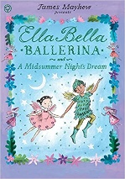 | A Midsummer Night’s  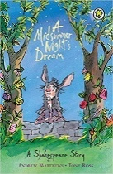  Dream | Julius Caesar  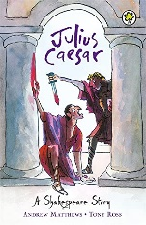 | The Tempest  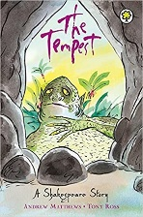 | Hamlet  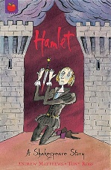 | Macbeth  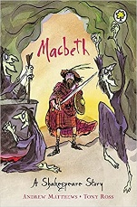
SPRING TERM | Outcome: to perform a story  Purpose: to entertain | Outcome: to perform a story  Purpose: to entertain | Outcome:  To write instructions on how to create a potion.  Purpose:  To instruct | Outcome:  To write a letter to Puck  Purpose:  to entertain | Outcome:  To write a persuasive speech  Purpose: to persuade | Outcome:  To write a playscript  Purpose: to entertain | Outcome:  To write a soliloquy  Purpose: to entertain | Outcome:  To write an atmospheric setting description of the heath  Purpose:  To entertain

*Within this document, reference is made to the protected characteristics by UK law, the 5 Plagues of the Developing Reader (Lemov, 2016) and to key themes identified within the texts.

